Team508: Structural and Thermal Management of an Automotive Battery

Spring Project Plan
Taylor Bethmann
Austin Robertson
Kaleb Sands
Skyler Heft
Mark Hibyan
FAMU-FSU College of Engineering

Spring Project Plan
During the fall semester, all of project planning was completed. This includes a layout of the project scope and customer needs, as well as a generation and selection of concepts. Now that the concepts for the design have been established, prototyping and testing needs to be carried out in order to validate the designs. Thus, the primary goal for the spring semester is to prototype, test, and build the project design. The following outline illustrates the milestones and time at which these spring tasks are planned to be completed. It should be noted that the time stated for each task is a deadline, and the tasks can be completed prior to this date.

Spring Plan Outline
- Modeling (Present – Jan 13)
  - Detailed CAD model of the design (Dec 2)
  - Finalize and approve design (Dec 3)
  - Simulate thermal and structural response in COMSOL (Jan 13)
- Purchasing and Construction (Jan 24 – Feb 28)
  - Purchase Nissan Leaf battery modules (Jan 24)
  - Purchase materials for enclosure (Jan 24)
  - Machine enclosure (Feb 25)
  - Connect BMS, modules, and other components (Feb 28)
- Testing and Validation (Feb 28 – Mar 20)
  - Create small scale prototype of the design (Feb 28)
  - Shaker test for mechanical vibration stability (Mar 6)
  - Cycler test for heat generation and thermal load analysis (Mar 6)
  - Drop test for impact testing carried out on scaled prototype (Mar 13)
  - Analysis on testing data with SAE standards (Mar 20)
- Presentations (Apr 3 – May 1)
  - Assemble final presentation (Apr 3)
  - Practice final presentation (Apr 7)
  - Engineering Design Day 2020 (Apr 16)
  - Graduation (May 1)

Timeline

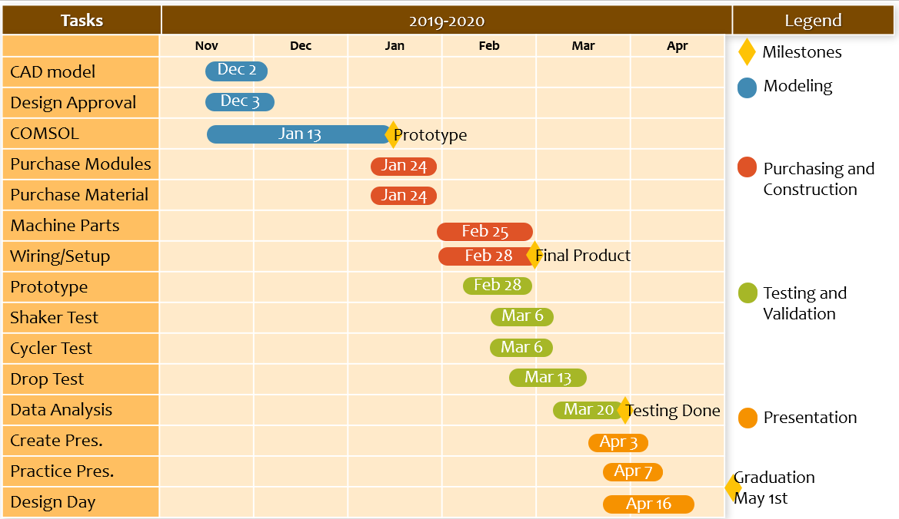
The figure below displays the timeline generated from the tasks outlined above. The difference in color is associated with the general topic in which that task falls under. The blue dates signify the Modeling tasks, red signifies Purchasing and Construction, green is Testing and Validation, yellow is Presentations, and the stars refer to milestones. These milestones are references with a star to symbolize a goal to the end of each categorical tasks.
Figure 1. Timeline of spring project plan.

